EITS Supervisor Dashboard (Veneer Pressing) User Guide

**Main Page Veneer Pressing**

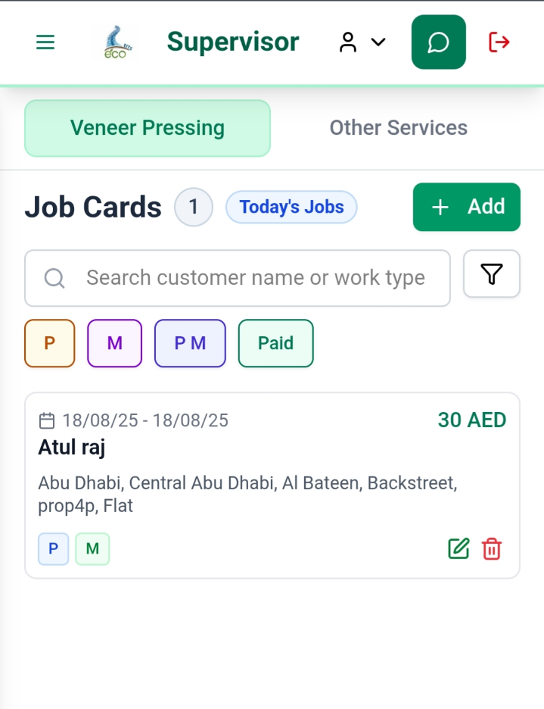

On main page click select Veneer Pressing after that click on Add button to proceed further.

Then this job card will appear.

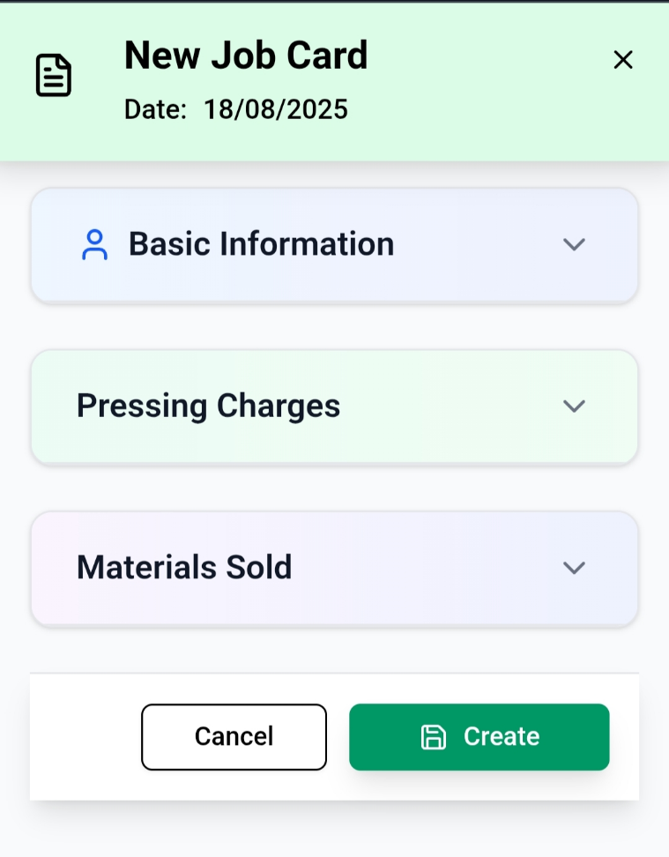

1. **Basic Information**

* Click on basic information
* You just need to search customer name and all the information will automatically be filled in according to user data.

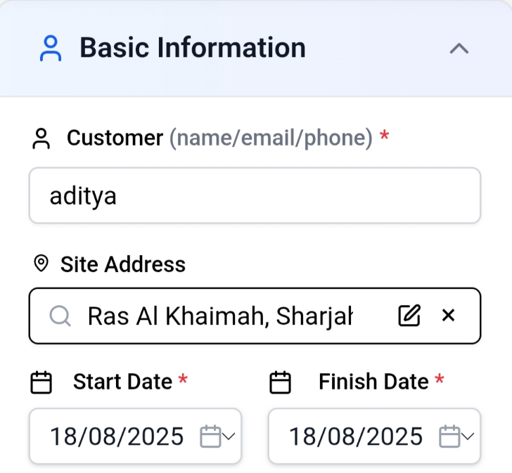

* You can search the Customer name as per their email, name or phone number.
* You can select the date according to their urgency.

1. **Pressing Charges**

* In pressing charges select work type according to customer preferences.
* Add size thickness and sides (Quantity).
* After that add remark, completely optional.
* Click on Add charges button to add more pressing charges slides.

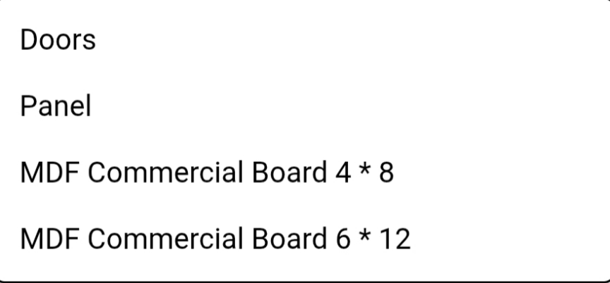

**(Work Type)**

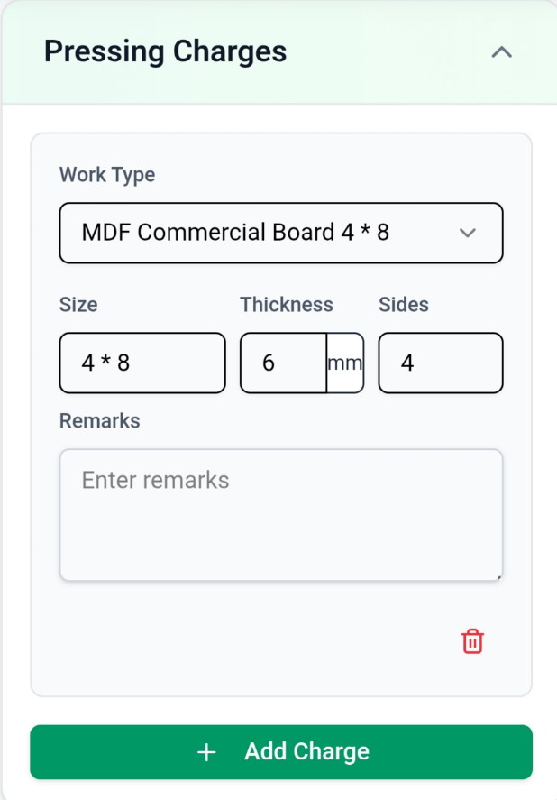

1. **Materials Sold**

* Select Work Type.
* Add size and quantity.
* Click on Add material to add more of these slides, can even delete this if needed.

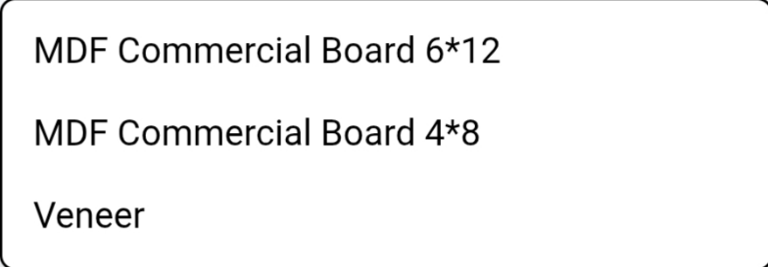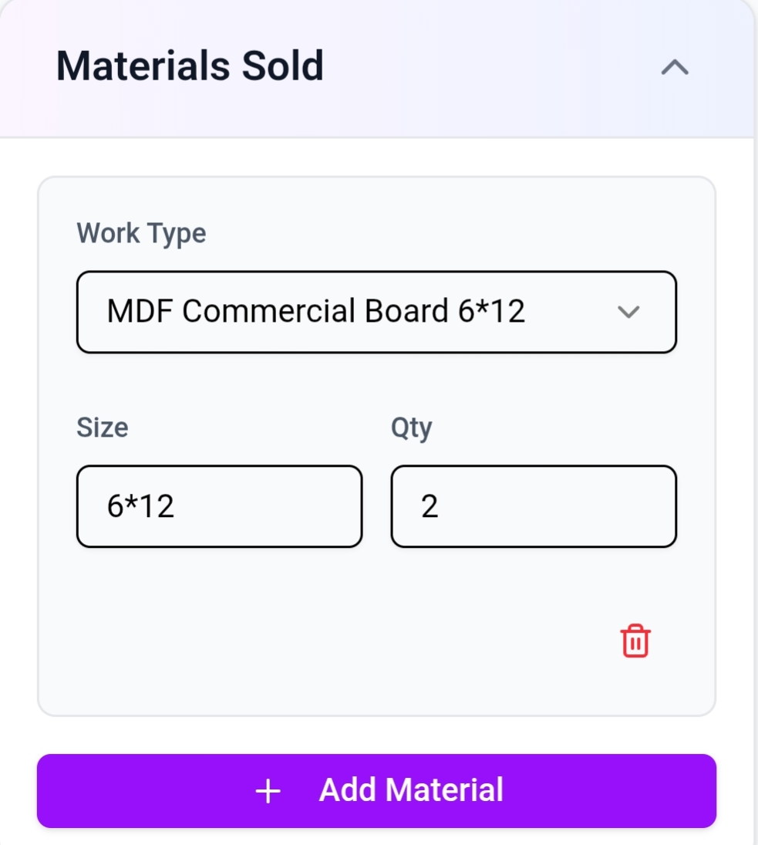

Finally Click on create button to create a new job card

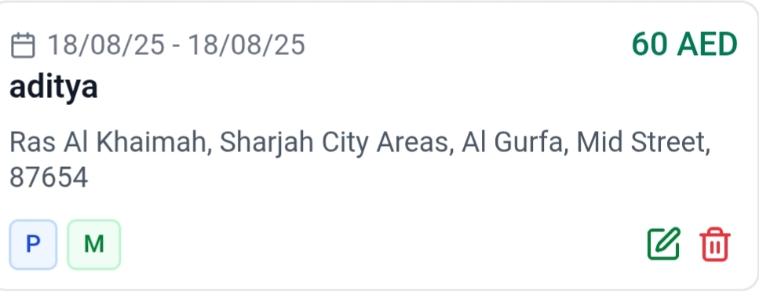

* The final Job card will look like this
* If you need to make some changes in job card then click on edit button

**EITS Supervisor Dashboard (Other Services) User Guide**

**Main Page**

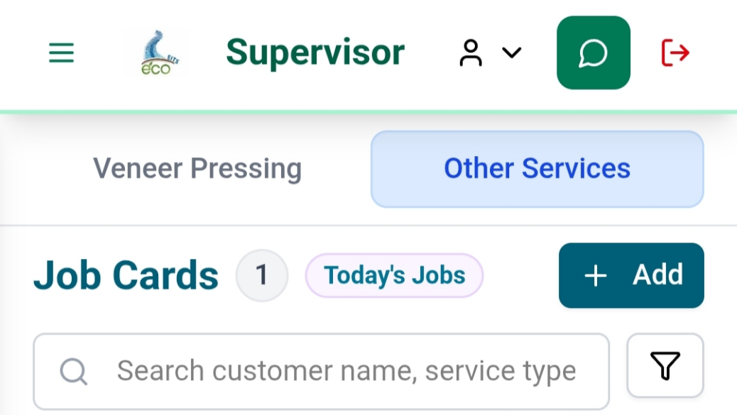

On main page click select **Other** **Services** after that click on **Add** **button** to proceed further.

Then this job card will appear.

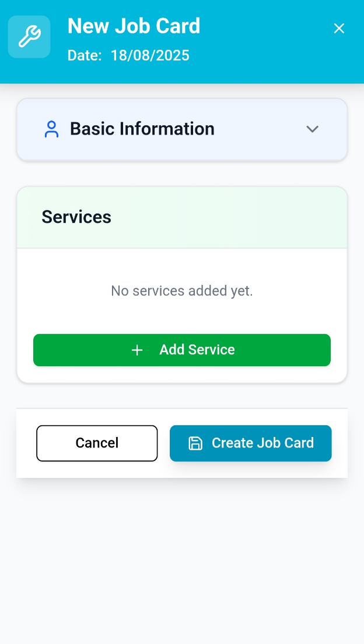

1. **Basic Information**

* Click on basic information
* You just need to search customer name and all the information will automatically be filled in according to user data.

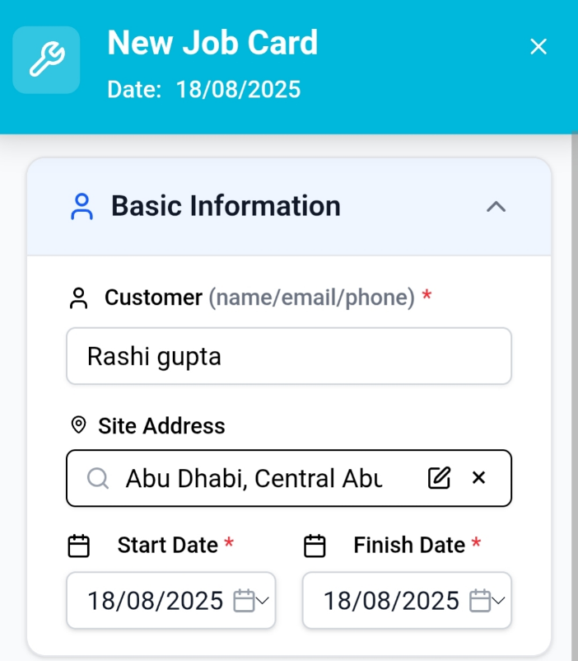

1. **Services**

* In services section click on **Add** **Services** button.

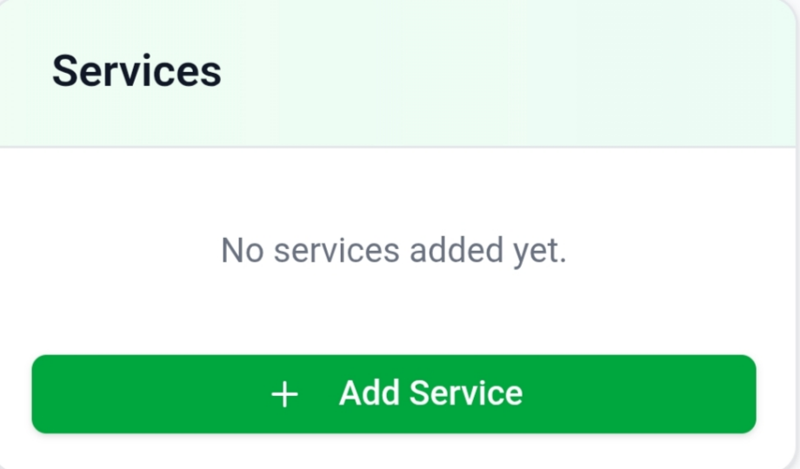

* Then this form will appear:

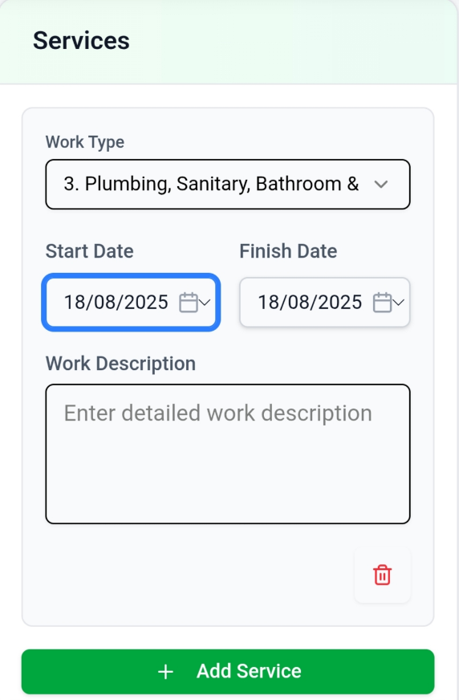

* Select any work type according to preferences.

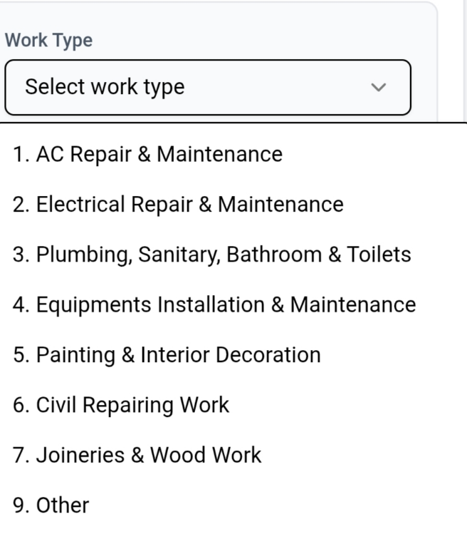

* Then select starting and ending date.
* Add description (optional)
* Click add services to add more of these

After that click on **Create Job Card** to create card

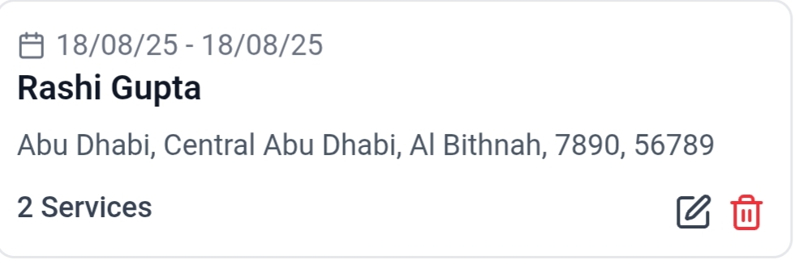

* The final Job card will look like this
* If you need to make some changes in job card then click on edit button

**Document Title:** EITS Supervisor User Guide

* **Package Number:** 001
* **Author:** Kartik Kumar, Atul Raj
* **Approved By:** Amit Gupta
* **Created Date:** [18/08/2025]
* **Last Updated:** [18/08/2025]
* **Version:** 1.0.0
* **Status:** Draft
* **Confidentiality Level:** Internal Use
* **Developed at:** Gennext IT Management & Consulting